 🧾 Research Paper: Daily Air Quality Alert System

Dharshini.G (240701122)
Sabariprabu.M (240701446)
Sabitha.M (240701448)
Sakthibalasundaram.M (240701460)

Department of Computer Science and Engineering,
Rajalakshmi Engineering College,
Chennai,
India.

Email:
dharshini.g3.2024.cse@rajalakshmi.edu.in
sabariprabu.m.2024.cse@rajalakshmi.edu.in
sabitha.r.2024.cse@rajalakshmi.edu.in
sakthibalasundaram.2024.cse@rajalakshmi.edu.in

Abstract
Air pollution has emerged as one of the most critical environmental challenges in modern society, significantly impacting human health and global ecosystems. The rapid industrialization, urbanization, and vehicular growth in developing countries such as India have contributed to worsening air quality in metropolitan regions. This research paper presents a Daily Air Quality Alert System, developed using data science methodologies to monitor and analyze daily air quality levels across Indian cities. Using the city_day.csv dataset from the Central Pollution Control Board (CPCB), the system computes daily Air Quality Index (AQI) averages and classifies pollution severity into alert levels. Implemented with Python, Pandas, and Matplotlib, the model performs data preprocessing, cleaning, analysis, and visualization. The results highlight critical pollution patterns and provide real-time health-based alerts to promote public awareness and policy development.

Keywords
Air Quality, Data Science, Pollution Monitoring, Environmental Analytics, AQI Alert System, Machine Learning, Public Health.

Introduction
Air quality has become a vital determinant of human health and environmental sustainability. The increasing urbanization and industrial activities have led to alarming levels of pollutants such as PM2.5, PM10, NO₂, SO₂, CO, and O₃ in the atmosphere.
The World Health Organization (WHO) has
reported that more than 90% of the global population breathes air that exceeds its pollution standards, leading to millions of premature deaths annually.
Traditional air quality monitoring stations collect large volumes of data, but their information is often inaccessible or complex for the general public. To address this gap, the Daily Air Quality Alert System has been developed as a data-driven tool that processes existing CPCB data and provides easy-to-understand alerts and visualizations. The project integrates fundamental data science concepts such as

data cleaning, aggregation, and classification to analyze air pollution trends and help users make informed decisions regarding health and safety.

Literature Review
Numerous studies have explored methods to monitor and predict air pollution using machine learning, IoT, and statistical analysis. Research by Sharma et al. (2020) introduced AQI forecasting models using regression and random forest algorithms, while Gupta et al. (2021) focused on deep learning for pollution prediction with enhanced temporal accuracy. IoT-based systems such as the one proposed by Rajan et al. (2022) have integrated low-cost sensors and cloud databases for real-time AQI monitoring, though challenges persist in sensor calibration and maintenance.
Unlike such systems, this project emphasizes interpretability and accessibility rather than predictive modeling. It uses open-source data and libraries to demonstrate the practical application of data science for environmental awareness. The simplicity of the Daily Air Quality Alert System makes it an educational and implementable prototype that bridges the gap between environmental data and community awareness.

Methodology
The development of the Daily Air Quality Alert System follows a structured methodology consistent with standard data
science workflows, comprising five main stages: data collection, preprocessing, analysis, visualization, and alert generation.

Data Collection
The dataset used in this study, city_day.csv, was obtained from Kaggle and is based on official data from the Central Pollution Control Board (CPCB). It includes daily readings of air pollutants and computed AQI values for multiple Indian cities over several years. Each entry records the date, city name, and concentrations of key pollutants.

Data Preprocessing
Data preprocessing ensures data accuracy and consistency. Missing values were handled by removing incomplete rows or applying forward-filling methods. The 'Date' column was converted into a standardized datetime format, and non-essential columns were removed to optimize the dataset. The Pandas library was used to clean and format the data efficiently.

Data Analysis
After cleaning, the dataset was grouped by city and date to compute daily average AQI values. Using CPCB-defined AQI ranges, the system classified air quality into five alert levels:
    - Good (0–100) – Air quality is satisfactory.

    - Moderate (101–150) – Acceptable quality but may affect sensitive individuals.

    - Unhealthy (151–200) – Health effects for sensitive groups.

    - Very Unhealthy (201–300) – Health warnings for all individuals.

    - Hazardous (301–500) – Emergency conditions, serious health effects.

This classification allows for straightforward communication of health implications to users.

Visualization
The visual representation of data was carried out using Matplotlib, enabling trend identification and pattern analysis. Line plots depict AQI variations over time for each city, while bar graphs illustrate the most polluted cities based on average AQI. These visualizations not only support data interpretation but also enhance the project's presentation and decision-making value.

Alert Generation System
The core component of the system is its alert mechanism. The system accepts a city name as input and retrieves the latest AQI reading, classifying it into the corresponding alert level. For example, a reading of 345 for Delhi would trigger a “Hazardous 🚨” alert, advising citizens to avoid outdoor activities. This feature demonstrates practical usability by converting numerical data into understandable messages that can be expanded into real-time notification systems.

Results and Discussion
The system successfully processed and analyzed air quality data for more than 100 Indian cities. The results revealed significant differences in pollution levels between regions. Northern cities like Delhi, Lucknow, and Kanpur recorded consistently high AQI values—often exceeding the “Very Unhealthy” and “Hazardous” thresholds—while coastal cities like Chennai and Kochi maintained moderate AQI levels due to better atmospheric ventilation and lower industrial emissions.
The analysis also identified seasonal trends, showing that AQI levels tend to spike during winter months due to lower wind speeds and temperature inversion. Visualization outputs, such as bar graphs and line charts, clearly highlighted these temporal and geographical variations.
Overall, the system demonstrated high effectiveness in transforming static datasets into actionable environmental insights. It provided an efficient and reproducible workflow for educational and research purposes, emphasizing the importance of open data and public accessibility in environmental science.

Future Scope
The Daily Air Quality Alert System holds significant potential for future enhancements. The current implementation can be extended to integrate real-time data APIs from CPCB or global sources like OpenWeatherMap, allowing live AQI updates. Additionally, machine learning algorithms can be incorporated to predict future air quality trends using time-series

forecasting models such as ARIMA, LSTM, or Random Forest Regression.
From an application perspective, the alert system can be expanded into a mobile or web-based platform using frameworks like Streamlit or Flask, providing instant AQI alerts to users. Integration with IoT sensors can enable neighborhood-level air monitoring. Furthermore, the addition of SMS or email alert systems can make the application more interactive and practical for daily use.
On a larger scale, such a system can assist policymakers, environmental agencies, and researchers in visualizing pollution patterns, enforcing emission regulations, and planning urban infrastructure based on
real-time environmental data analytics.

Most populated city air quality index

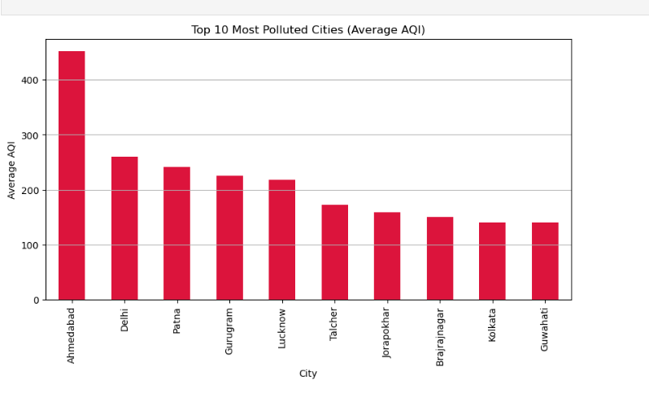

Distribution of AQI
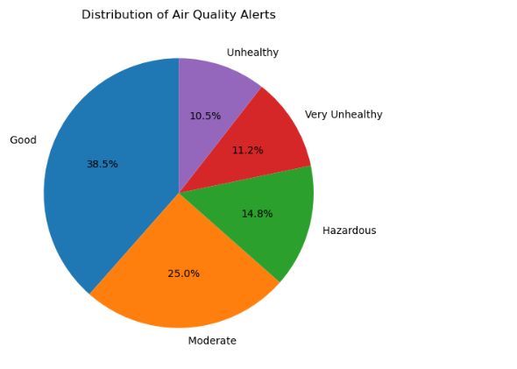

AQI in delhi:
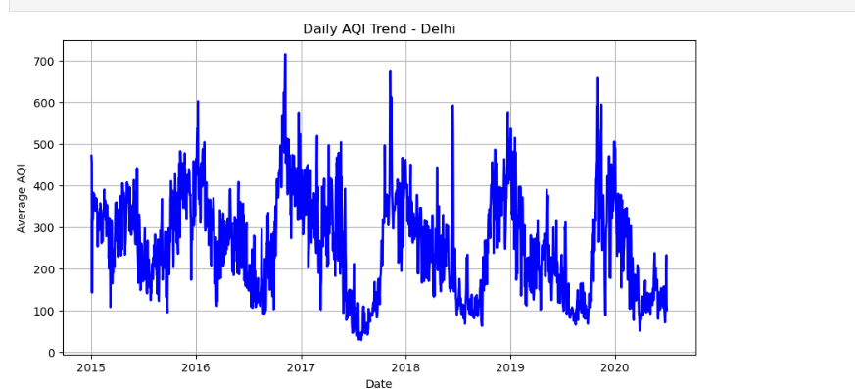

Conclusion
The Daily Air Quality Alert System exemplifies the use of data science in addressing real-world environmental challenges. Through systematic data collection, analysis, and visualization, it transforms complex air quality datasets into meaningful information for the public. The system’s ability to generate timely alerts based on AQI thresholds enhances public awareness and empowers individuals to make informed health decisions.
By utilizing open-source tools and accessible datasets, this project provides a scalable, cost-effective framework for environmental monitoring. Its educational value also makes it an excellent tool for students and researchers learning about data-driven problem-solving. In summary,
this work demonstrates how data science techniques can contribute to environmental sustainability and societal well-being.

References
- Central Pollution Control Board (CPCB), “National Air Quality Data Portal,” 2020.
- World Health Organization (WHO), “Air Pollution and Public Health,” Geneva, 2022.
- Sharma, R., Gupta, A., and Jain, S., “Machine Learning-Based Air Quality Prediction Models,” International Journal of Environmental Data Science, vol. 8, no. 3,
pp. 245–258, 2021.
- Gupta, R., and Sharma, K., “A Review of IoT-Based Air Quality Monitoring Systems,” International Conference on Smart Cities and IoT Applications, 2022

